Tool Guide – Dig

Introduction
Dig (Domain information groper) is a cli DNS lookup tool used to query domain name system records. You can use it to provide information about how a domain is structured and gather DNS information. You use dig during the reconnaissance phase to gather intelligence on targets.
Safety Disclaimer: Use only on networks and systems for which you have explicit authorisation. Unauthorized use of tools can be Illegal, unethical and harmful.

Setup and Launch
  - Step1: Open Deakin Detonator Toolkit
- Open Terminal in Linux
- Navigate to your Deakin Detonator Toolkit directory: (cd ~/Deakin-Detonator-Toolkit)
- Run DDT by using the following command line: (yarn run tauri dev)
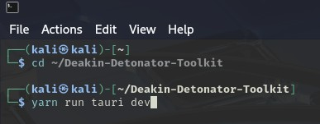
  - Step2: Find Tool-example
- Click on Tools to the left (or use the quick search bar)
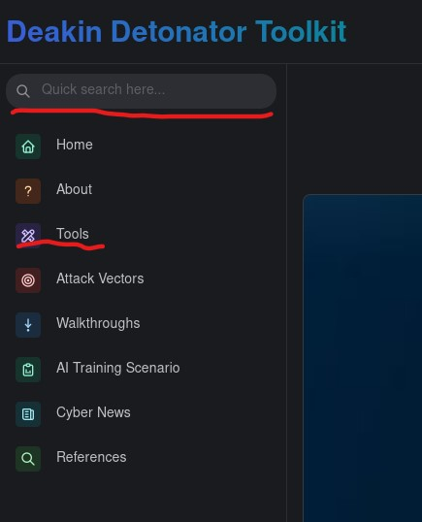
- If you clicked on Tools, scroll down and find Dig and click go

Configuration and Usage
  - Step3: Configuring Dig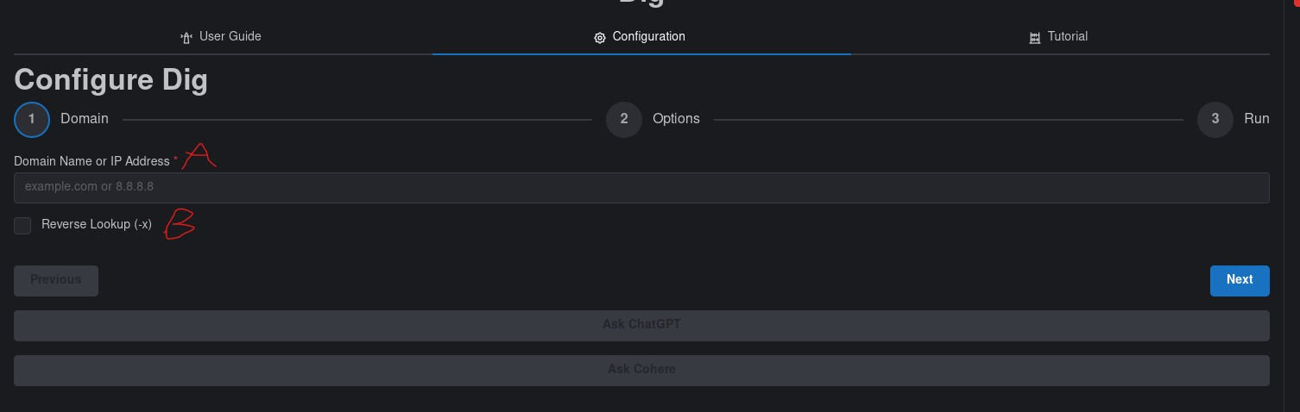
- Domain
  - Domain Name: input either the domain name (e.g. google.com) or an IP address (e.g. 8.8.8.8)
  - Reverse Lookup (-x): you want to use this when you have inputted an IP address in the domain name field, but it is unnecessary if you are searching a domain name. it essentially asks what hostname is associated with the IP address you are checking.
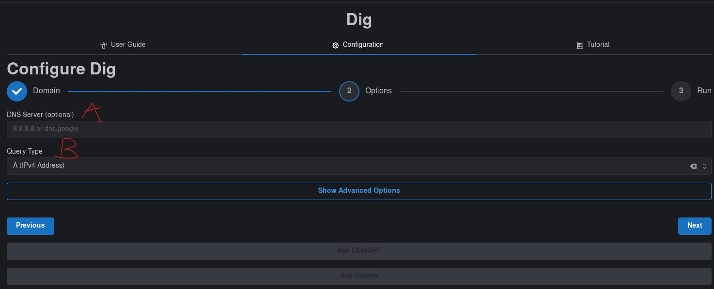
- Options(basic)
  - DNS Server (optional): you can input a DNS server that you want to use (e.g. 8.8.8.8 or dns.google)
  - Query type: Here you can choose the type of DNS record you are looking for, IPv4(A), IPv6(AAAA), Mail exchange(MX), Name Server(NS), Start of authority(SOA), text records(TXT), canonical name(CNAME), pointer(PTR), service(SRV, all records(ANY). Note (ANY) requests can be typically restricted/refused
  - You can either move ahead by clicking next or click the show advanced options for further configuration.
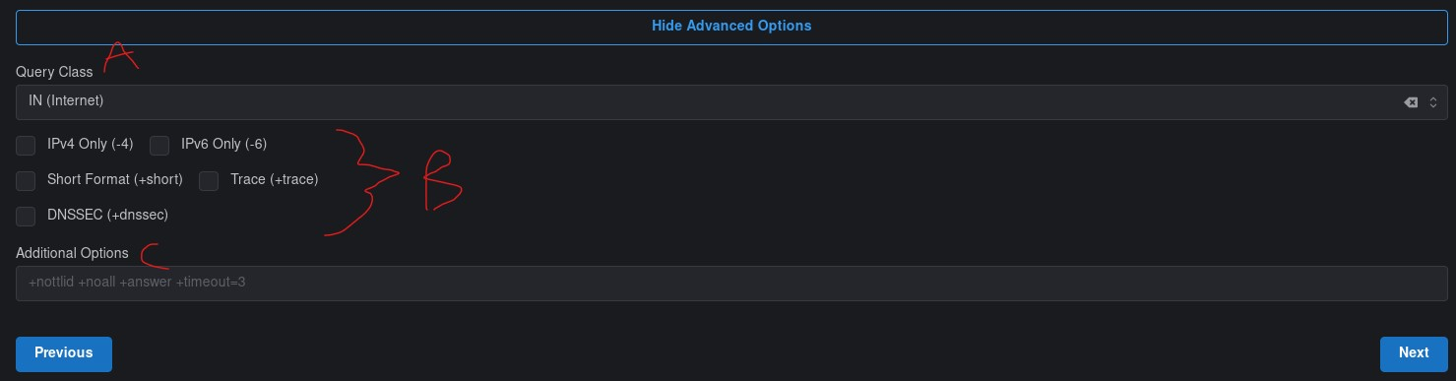
- Options(advanced)
  - Query Class: this tells dig what type of query you want, and there are three types.
    - IN (Internet): the default and standard option you most likely want to use.
    - CH (chaos): this is for querying information about DNS servers themselves.
    - HS (Hesiod): A legacy option, not too useful currently, unless you are dealing with very old systems.

    - IPv4 only (-4): forces dig to use only IPv4 when querying DNS
    - IPv6 only (-6): forces dig to use only IPv6 when querying DNS
    - Short format (+short): output only the results, and no extra information
    - Trace (+trace): trace the path taken, basically follow the steps the packets take.
    - DNSSEC (+dnssec): requests DNS server to respond with DNSSEC related information.
  - Additional options: Here you can place additional options that you may want to use, for example +nottlid, +noall, +answer, +timeout=3, +states and a few others.
  - Step4: Results
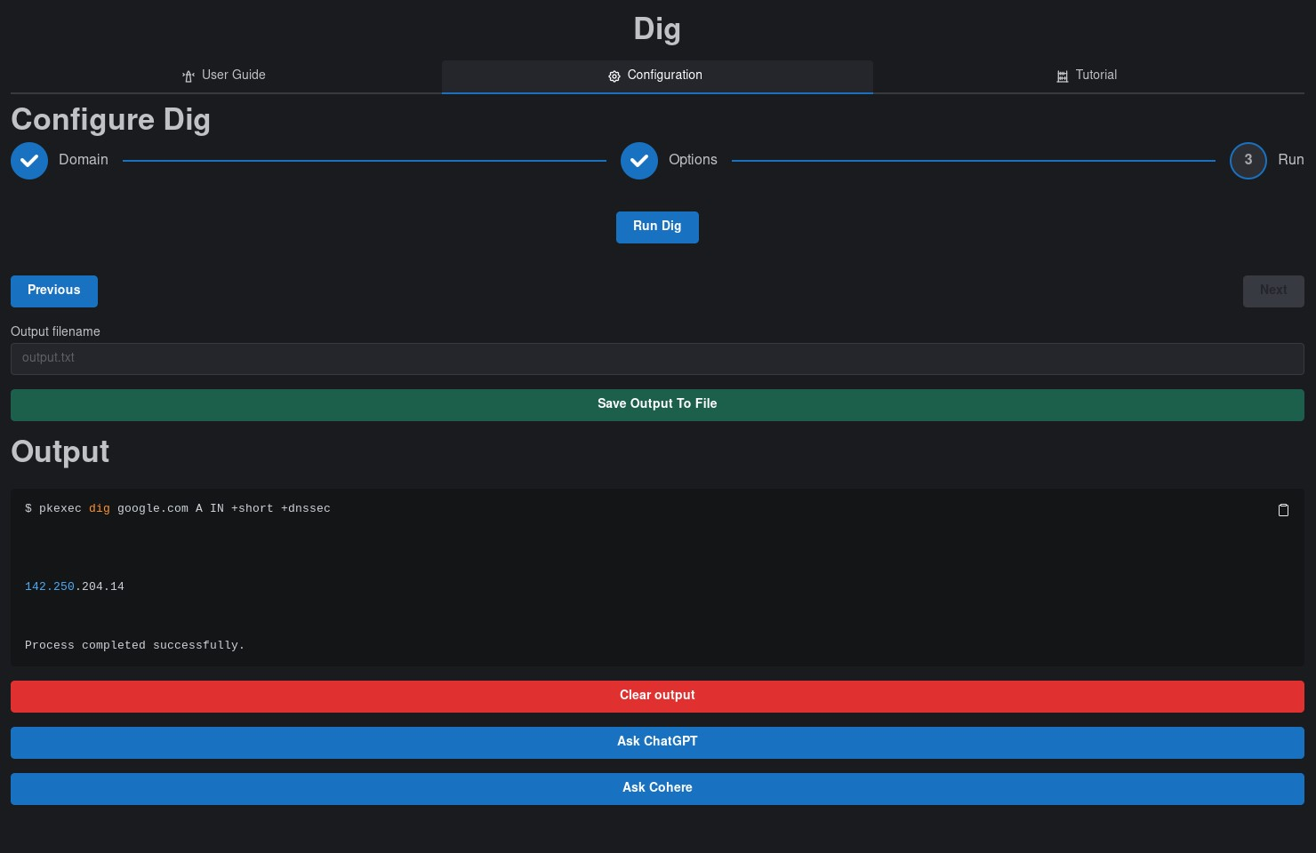
- You will be given an output that should end with “process completed successfully” and be sure to scroll up in the Output field to see the rest.
- Optional: You can save your output by filling out the new “Output filename” field with an appropriate name (output.txt) and then clicking “Save Output To File” button
- Optional: You can copy your output to your clipboard by clicking the little clipboard in the top-right of the output area.

Output Explanation
Note: your output will naturally be dependent on what domain/IP you checked and which options you selected, the following is non-comprehensive example output of domain “google.com”, query type “A (IPv4 address)”, Query Class “IN (internet)”, “Trace (+trace)”, “
- $ pkexec dig google.com A IN +short +dnssec
  - This is the command used by the dig tool with the details inputted.
- 142.250.204.14
  - The results we received
Without +short, there will be a lot of extra information that may or may not be useful to you.

